Worst Generals of the Civil War
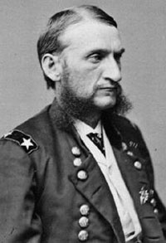
- Hugh Judson Kilpatrick [US]
General Kilpatrick was known for his reckless disregard for the lives of those soldiers under his command and his performance at Gettysburg bordered on criminal behavior. His “raid” on Richmond under the pretext of freeing Union prisoners ultimately cost lives. When General Kilpatrick commanded his cavalry in parades or battle and they looked quite professional. However, his camp was another story. Kilpatrick’s lack of proper discipline resulted in his camps being unkempt and disorderly. In July of 1863, at the Battle of Gettysburg, Kilpatrick, in command of his cavalry, was later accused of using poor judgment when he ordered a devastating charge on July 3. In an effort to repair the damage to his reputation caused this day, and in anticipation of post war political aspirations, he planned a raid on Richmond, Virginia in 1864. His plan was to attack the Confederate capital, cause as much devastation as possible, and free the Union soldiers held prisoner there. On March 1, while in route to implement this plan, he lost his nerve at the gates of Richmond, and retreated.

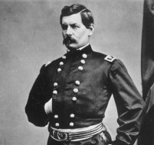
- George McClellan [US]
The master of over-estimation and slow movement, he constantly proclaimed himself the Savior of the Union, yet seemed unwilling to fight. McClellan repeatedly froze during close tactical command. At Rich Mountain he refused to support William Rosecrans, who had run into Rebels near the top of the mountain. At Ball's Bluff he did not support the advance of Edward Baker. He claimed he could not start the Peninsula Campaign until Ulysses S. Grant and Don Carlos Buell had taken Kentucky. By the time he finally started Grant and Buell were just north of the Mississippi-Tennessee border. At Yorktown a force of 13,000 Confederates held off between 60,000 and 80,000 Yankees for a month. Within sight of Richmond, Virginia, he retreated in spite of commanding a superior force. At Antietam, he had his opponent’s battle plans and still could not win. His successes were tempered by his refusal to pursue the Army of Northern Virginia. Finally it was decided in Washington to abandon the campaign and transfer most of his men.

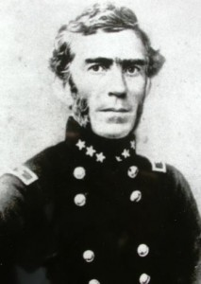
- Braxton Bragg [CS]
Bragg's problems are legendary. He showed little ability in communicating with his generals, refused to give them even modest decision-making capabilities, made weak strategic decisions and poor tactical decisions. His march to Kentucky, touted by some as a strategic masterpiece was little more than an attempt to protect Kirby Smith's flank from Don Carlos Buell. He simply assumed William S. Rosecrans would not attack once his force had been routed at Stone's River. It took him two days to find out the enemy was advancing on his position at Tullahoma, then chose to obey a 6-month-old order, retreating to Chattanooga. A brigade of men fooled him into retreating from that city. After Chickamauga he refused to destroy the Army of the Cumberland in spite of the advice of Nathan Bedford Forrest and James Longstreet. On Missionary Ridge, Tennessee he misplaced his line, then blamed his men for the loss.

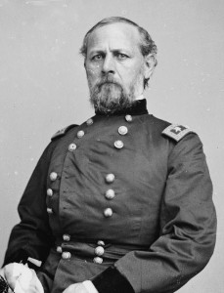
- Don Carlos Buell [US]
At the Battle of Shiloh, Buell's men arrive after the first day of battle, more than a week after he was ordered to be there. From Corinth he moved to secure the city of Chattanooga for the Union. Braxton Bragg [CS], moving from Tupelo, Mississippi, beat him there. Buell spread his troops along a 400-mile front that was easily pierced by Kirby Smith and Bragg in multiple places. During the Battle of Perryville he ordered Phil Sheridan to quit wasting ammunition, not realizing that a battle was taking place and that the Union commander was all that stood between Bragg and success. He failed, however, to pursue the retreating enemy. Buell was so bad that 20 of his senior officers petitioned President Lincoln to have their commanding general removed.

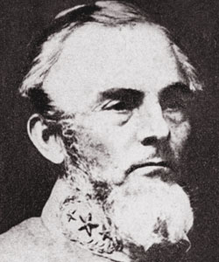
- Gideon Pillow [CS]
Gideon Pillow's friendship with James Polk won him a generalship in the United States Army under Winfield Scott during the Mexican War. He almost lost the battle of Cerro Gordo singlehandedly, so Scott assigned Joseph Hooker to be his chief-of-staff to help him. At Fort Donelson he led an attack that breached Union lines, then failed to consolidate his gains. Rather than surrender, Pillow fled. Suspended from command by order of Jefferson Davis for “grave errors in judgment in the military operations which resulted in the surrender of the army”. Despite his advantages at Fort Donelson, General Pillow’s inexplicable decisions led him to an embarrassing defeat. His decision to flee the fort, would tarnish is reputation beyond repair and for the rest of his life he would carry the failure made worse by the abandonment of his own men. In 1864 he returned to active duty during the Atlanta Campaign, losing, most notably, the battle of Lafayette Court House, where he outnumbered his opponent 4-to-1.

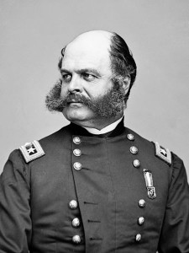
- Ambrose Burnside [US]
General Burnside’s leadership fiasco at Antietam allowed a Confederate division to contain the Union breakthrough. He pointlessly lost nearly 1,000 men. Abraham Lincoln asked him twice to take command of the Army of the Potomac and Burnside refused. In all fairness, Burnside knew he would not be a good overall commander. The third time Lincoln ordered him to take command. He is the chief architect of the futile, murderous assaults at Fredericksburg and his obvious failure at Petersburg where he bungled the follow-up to the explosion of the mine. In reaction to this failure he was sent on leave and never recalled. He also fought at the Wilderness and Spotsylvania where his poor leadership continued to be exemplified, appearing reluctant to commit his troops after the Fredericksburg experience. His name gave rise to the term "sideburns."

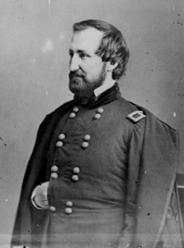
- William Rosecrans [US]
Early successes in Western Virginia, where George B. McClellan considered him "a silly fussy goose," did not predict Rosecrans future as a commanding officer. Appointed commander of the Army of the Cumberland in October, 1862, he almost lost the battle of Stone's River, then waited nearly 6 months to engage an enemy roughly 1/2 his size. His flawed strategy during the Tullahoma Campaign only succeeded because Rosecran's opposition was Braxton Bragg. Rather than consolidate his position in Chattanooga, he opted to move through the passes in Lookout Mountain. When he came out, with the mountain to his back, he fought the battle of Chickamauga, the worst Union loss in the Civil War. Trapped in Chattanooga he did little to relieve the suffering of his men. When Ulysses S. Grant relieved him of duty, there were fewer than 5 days of rations remaining (and his men were on half-rations).

- John Bell Hood [CS]
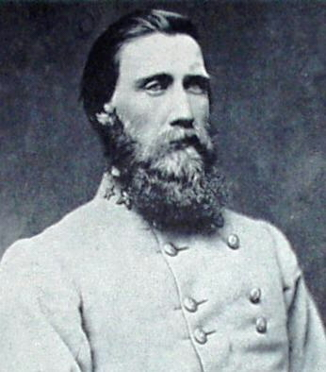
A good brigade and division commander John Bell Hood is probably the best example of someone who had an inability to find any success during the Civil War. He lost a leg and the use of one of his arms after being severely wounded at the Battles of Gettysburg and Chickamauga in 1863. Appointed commander of the Army of Tennessee in July, 1864, Hood lost all the major battles he fought. Following the surrender of Atlanta, his aggressive tactics ultimately proved futile against William T. Sherman’s larger Union force, and Hood later suffered a series of bitter defeats. He lost the battle of Allatoona Pass, and lost the battles of Spring Hill, Franklin and Nashville.

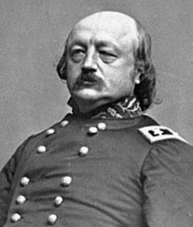
- Benjamin Butler [US]
Powerful politician who became a Union General after successfully relieving Washington D. C. following the bombardment of Fort Sumter, Butler was ordered to assume command of the "Department of the West", Union gains around New Orleans. His dictator-style military government of New Orleans showed no respect for civilians. The nickname “Beast of New Orleans” was bestowed on the general, and Confederate President Jefferson Davis declared him to be an outlaw to be executed when caught. Relieved of duty by Lincoln, he was eventually given command of the Army of the James. In the conduct of tactical operations in Virginia, Butler was almost uniformly unsuccessful. His first action at Battle of Big Bethel was a humiliating defeat. Landing his 40,000 men at Bermuda Hundred and City Point, rather than immediately striking as ordered, his offensive was bogged down, immobilized by P. G. T. Beauregard and an army never exceeding 13,000 men (a good deal of whom were irregulars) and he was unable to accomplish any of his assigned objectives. In January, 1865, Lincoln finally removed him from command. He was a failure as both a politician and general officer.

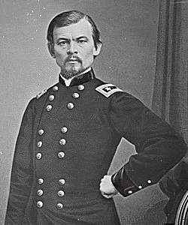
10. Franz Sigel [US]
General Sigel opened the Valley Campaigns of 1864, launching an invasion of the Shenandoah Valley in which he was severely defeated by General Breckenridge at the Battle of New Market on May 15, 1864. This battle was particularly embarrassing due to the prominent role young cadets from the Virginia Military Institute played and was his relieved of his command for “lack of aggression”. He was unable to shake the reality that he was defeated by a charge of young Virginia Military Institute cadets and his military aspirations ended abruptly serving the rest of the war without any active commands.

- Nathaniel Prentiss Banks [US]

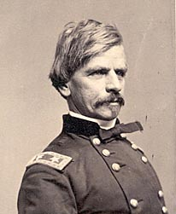
In the Shenandoah Valley, General Banks lost 30 percent of his troops when he was routed by Stonewall Jackson and due to his tremendous loss of supplies was dubbed “Commissary Banks” by the Confederates. As part of Pope’s army, he was defeated at Cedar Mountain again by Jackson in the disastrous Red River Campaign as well as the Second Battle Bull Run. After a brief stint in the capital’s defenses he went to New Orleans to replace Benjamin F. Butler. His operations against Port Hudson were met with several bloody repulses eventually falling only after the surrender of Vicksburg made it indefensible.

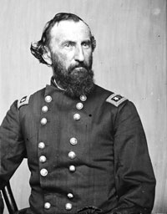
12. John A. McClernand [US]
Although a lifelong Democrat, this "friend" of Abraham Lincoln rushed to Fort Donelson and attacked without orders. He failed to anchor his line allowing Gideon Pillow to nearly break out of the besieged fort. At Shiloh he supported Sherman and Prentiss with an early attack, then pulled back to Grant's Last Line. During the Siege of Vicksburg, Grant relieved McClernand of his command by citing his unrestrained and unauthorized communication with the press, finally putting an end to a rivalry that had caused Grant discomfort since the beginning of the war.

