Understanding the Articles of Confederation
“Our First Constitution”

What type of government or system was first created? Why?
Why might this form of government struggle to be successful?

Who has more power: The individual states or the national government? Why might this be the case?

Complete the table below by including 3-4 examples for each.

Individual States: Powers Granted/Given  (what can they do or control?) | National Congress/Government: Powers Granted/Given  (what can they do or control?)
Individual States: Powers Limited  (what can they NOT do or control?) | National Congress/Government: Powers Limited  (what can they NOT do or control?)

Give at least one example of how the Articles of Confederation are SIMILAR to our current government and at least one example of how the Articles of Confederation are DIFFERENT to our current government.

Using the Articles of Confederation, what 3 connections can you make to previous learning? Use specific powers given, statements, or functions of the new government to complete your connections.
Why did the members of the Continental Congress create this form of government in this manner? Where did these ideas and beliefs come from?

1.

2.

3.

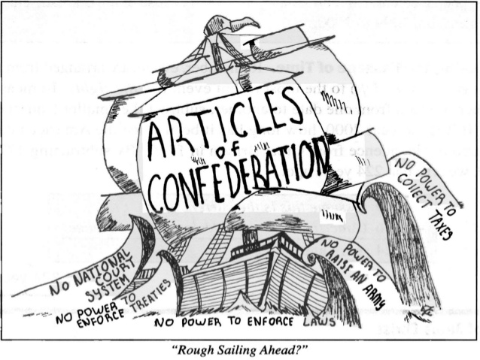
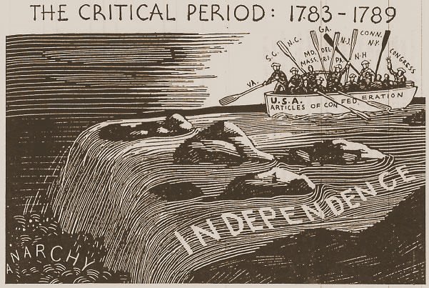

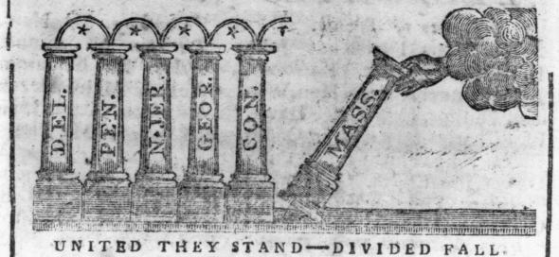

Using any or all of the above images, what are the biggest problems or challenges under the Articles of Confederation?

