Top 10 Worst American Civil War Generals
Posted by Shell Harris on May 24, 2009 in History | 32,964 Views | 47 Responses

In determining the worse Generals of the American Civil War, this list will take us from battlefield blunders to portraits on urinals. No doubt, I will likely have a great deal of criticism regarding my choices, as this is certainly a passionate and controversial subject for most individuals who love American Civil War history.

10. Hugh Judson Kilpatrick (USA)
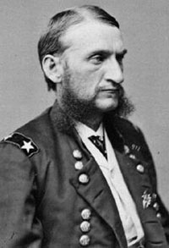
General Kilpatrick was known for his reckless disregard for the lives of those soldiers under his command and his performance at Gettysburg bordered on criminal behavior. His “raid” on Richmond under the pretext of freeing Union prisoners was a joke that ultimately cost lives. When General Kilpatrick commanded his cavalry in parades or battle and they looked quite professional. However, his camp was another story. Kilpatrick’s lack of proper discipline resulted in his camps being unkempt and disorderly.
In July of 1863, at the Battle of Gettysburg, Kilpatrick, in command of his cavalry, was later accused of using poor judgment when he ordered a devastating charge on July 3. In an effort to repair the damage to his reputation caused this day, and in anticipation of post war political aspirations, he planned a raid on Richmond, Virginia in 1864. His plan was to attack the Confederate capital, cause as much devastation as possible, and free the Union soldiers held prisoner there. On March 1, while en route to implement this plan, he lost his nerve at the gates of Richmond, and retreated.

9. William S. Rosecrans (USA)
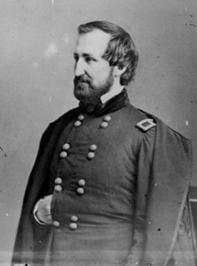
Appointed commander of the Army of the Cumberland in October 1862, General Rosecrans almost lost the battle of Stone’s River and then waited almost six months to engage an enemy of a much smaller force. Referred to by General McClellan as “a silly fussy goose,” it did seem to accurately predict General Rosecrans military future as a commanding officer.
He fought the battle of Chickamauga, the worst Union loss in the Civil War. Trapped in Chattanooga he did little to relieve the suffering of his men. When General Grant relieved him of duty, he had fewer than five days of rations remaining with his troops already being on half-rations.
Also problematic was his propensity to micro-manage the movements of units instead of relying on his chain of command. Finally, he was accused of disgracefully leaving the battlefield at Chickamauga and he was relieved of duty.

8. Don Carlos Buell (USA)
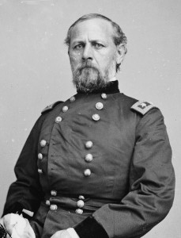
General Buell led four divisions along the Memphis and Charleston Railroad towards Chattanooga while repairing the line. With his supply line destroyed by Confederate cavalry, his movement came to a halt. With Confederate invasion of Kentucky, General Buell was forced to fall back north to protect the line of the Ohio River. Dissatisfied with his progress, the authorities ordered him to turn over command to George H. Thomas on September 30, 1862, but the next day this order was revoked. On October 8 he fought the indecisive battle of Perryville, which halted a Confederate invasion that was already faltering. He failed, however, to pursue the retreating enemy and for this was relieved of his command on October 24, 1862.

7. Gideon Pillow (CSA)
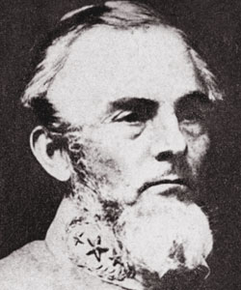
Suspended from command by order of Jefferson Davis for “grave errors in judgment in the military operations which resulted in the surrender of the army” at Fort Donelson. Despite his advantages at Fort Donelson, General Pillow’s inexplicable decisions led him to an embarrassing defeat. In his memoirs regarding the Battle of Fort Donelson in February 1862, General Grant wrote of his Confederate foe, “I had known General Pillow in Mexico, and judged that with any force, no matter how small, I could march up to within gunshot of any entrenchments he was given to hold.” His decision to flee the fort, would tarnish is reputation beyond repair and for the rest of his life he would carry the failure made worse by the abandonment of his own men.

6. Nathaniel Prentiss Banks (USA)
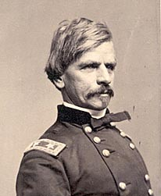
In the Shenandoah Valley, General Banks lost 30 percent of his troops when he was routed by Stonewall Jackson and due to his tremendous loss of supplies was dubbed “Commissary Banks” by the Confederates. As part of Pope’s army, he was defeated at Cedar Mountain again by Jackson in the disastrous Red River Campaign as well as the Second Battle Bull Run. After a brief stint in the capital’s defenses he went to New Orleans to replace Benjamin F. Butler. His operations against Port Hudson were met with several bloody repulses eventually falling only after the surrender of Vicksburg made it indefensible.

5. Franz Sigel (USA)
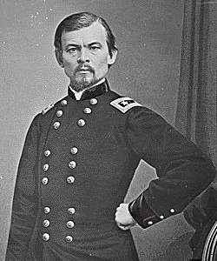
General Sigel opened the Valley Campaigns of 1864, launching an invasion of the Shenandoah Valley in which he was severely defeated by General Breckenridge at the Battle of New Market on May 15, 1864. This battle was particularly embarrassing due to the prominent role young cadets from the Virginia Military Institute played and was his relieved of his command for “lack of aggression”. He was unable to shake the reality that he was defeated by a charge of young Virginia Military Institute cadets and his military aspirations ended abruptly serving the rest of the war without any active commands.

4. Braxton Bragg (CSA)
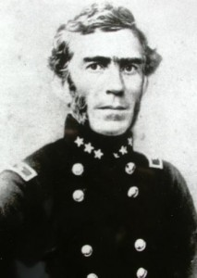
General Bragg’s problems were legendary on the battlefield. He lacked the ability to communicate with his generals. This problem was magnified by his chronic indecisiveness. His march to Kentucky, touted by some as a strategic masterpiece, was little more than a pathetic attempt to protect a weakening cause. It took him two days to discover the enemy was advancing on his position at Tullahoma, then chose to obey an order over six months old, retreating to Chattanooga. There it only took a brigade of men to fool him into a full retreat from that city. After Chickamauga, he refused to destroy the Army of the Cumberland in spite of the sound advice of Generals Forrest and Longstreet. At Missionary Ridge, he grossly misplaced his line then blamed his men for the loss.

3. Ambrose Everett Burnside (USA)
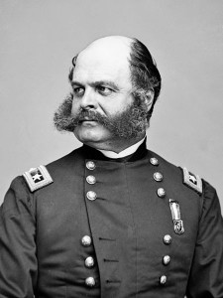
General Burnside’s leadership fiasco at Antietam allowed a Confederate division to contain the Union breakthrough. He is also the chief architect of the futile, murderous assaults at Fredericksburg and his obvious failure at Petersburg where he bungled the follow-up to the explosion of the mine. In reaction to this failure he was sent on leave and never recalled. He finally resigned on April 15, 1865. He also fought at the Wilderness and Spotsylvania where his poor leadership continued to be exemplified, appearing reluctant to commit his troops after the Fredericksburg experience.

2. George Brinton McClellan (USA)
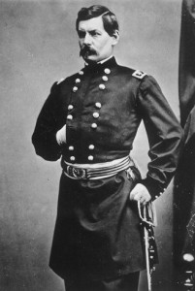
The master of over-estimation and slow movement, he constantly proclaimed himself the Savior of the Union, yet seemed unwilling to fight. At Antietam, he had his opponent’s battle plans and still could not win. Safely entrenched at Harrison’s Landing General McClellan began condemning the War Department, Lincoln, and Stanton, blaming them for the defeat. Finally it was decided in Washington to abandon the campaign and transfer most of his men to John Pope’s army in northern Virginia. There were charges that McClellan-now called by the press “Mac the Unready” and “The Little Corporal of Unsought Fields” was especially slow in cooperating.

1. Benjamin Franklin Butler (USA)
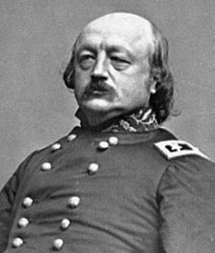
The nickname “Beast of New Orleans” was bestowed on the general, and Confederate President Jefferson Davis declared him to be an outlaw to be executed when caught. General Butler was so detested in the South that long after the war, chamber pots with Butler’s portrait in the bottom were found in many Southern homes.
In the conduct of tactical operations in Virginia, Butler was almost uniformly unsuccessful. His first action at Battle of Big Bethel was a humiliating defeat. Furthermore, at Petersburg rather than immediately striking as ordered, his offensive was bogged down, immobilized by the greatly inferior force of Confederate General P.G.T. Beauregard, and he was unable to accomplish any of his assigned objectives. But it was his mismanagement of the expedition against Fort Fisher in North Carolina that finally led to his recall by General Grant in December. He resigned his commission on November 30, 1865. He was a failure as both a politician and general officer; and considered by many as the ugliest general officer on both sides,

