The 10 Best Generals of the Civil War

Barry C. Jacobsen -- 04/20/2015
Barry C. Jacobsen is a former Green Beret and the publisher of The Deadliest Blogger.

The American Civil War is a source of great fascination to millions of military aficionados. More Americans died in this conflict than any other American has engaged in, before or since. Many of the soldiers who served and the men who led them were amateurs, products of the State Militia system. As is often the case, Americans rose to the challenge, learning on the job the grim lessons of battle. The Civil War produced many examples of leadership, both wretched and inspiring. It is not surprising that America’s greatest conflict produced some of its best generals. Of these, most worth graduates of the United States Military Academy at West Point (or of some other equivalent) and had served at least some time as officers in the “Regular” Army. One of the finest commanders was a gifted amateur, a born military genius who found his calling in the cauldron of conflict.

10. Jubal Early, CSA
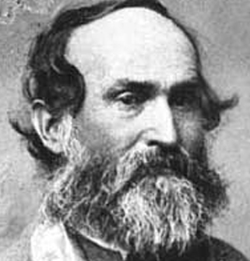
"Old Jube” to his soldiers, the peppery-tempered Confederate lieutenant general commanded Jackson’s Second Corp late in the war. He learned his trade as one of Jackson’s Brigade and Division commanders, and Early resembled his brilliant commander in spirit and his fondness for rapid maneuver. During the three-day Battle of Gettysburg, Early’s division occupied York, Pennsylvania—the largest Northern town to fall to the Rebels during the war. In 1864 he led the last Confederate invasion of the North, reaching the defenses of Washington. Unable to break the defenses, he withdrew to Virginia, commenting, “We haven't taken Washington, but we scared Abe Lincoln like hell!”

9. George Gordon Meade, USA
Nicknamed “Old Snapping Turtle,” Meade seldom gets much credit as a commander, despite defeating the great Robert E. Lee at Gettysburg, the decisive battle of the war. Though a West Point graduate and veteran of the Mexican War, Meade returned to service during the Civil War as a “captain of volunteers.” He had to serve in lesser positions throughout the war while less capable men. A successful and aggressive brigade and division commander, Meade distinguished himself at the Second Battle of Bull Run and the Battle of South Mountain. When another General resigned days before Gettysburg, Meade was tapped to command the Army of the Potomac after four senior generals turned President Abraham Lincoln down. With no time to organize his staff or to assert his authority over subordinates, he found himself in command of the Union forces at the greatest battle of the Civil War. At Gettysburg, Meade showed sound judgment in his choice of terrain. Despite disobedience, Meade held his position for three days, allowing Lee’s army to break itself against the Union’s strong positions. Meade was criticized after the battle for not pursing Lee’s retreating army more aggressively, but this can partially be explained by the loss of so many men during the battle (some 23,000 killed, wounded or missing), and the lack of support of his chief of staff.

8. James Longstreet, CSA
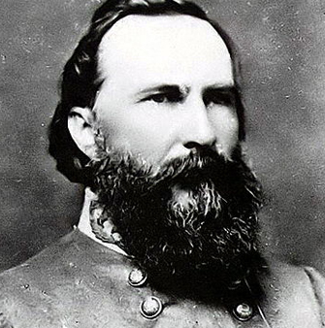
Lee’s “Old War Horse,” Longstreet was the anvil upon which the Union forces so often broke (or were hammered). A master of conducting attack or defense in forested terrain, he devised novel approaches at both Chickamauga and the Wilderness. Longstreet was known for his calm temperament in the midst of battle, a rare gift. At Gettysburg he famously disagreed with Lee about the place and conduct of the battle; he was, arguably, correct in his assessments. Longstreet’s flanking attack at the Battle of the Wilderness rolled up Union troops “like a wet blanket." Only Longstreet’s accidental wounding, which brought the attack to a halt, saved Grant’s army from severe defeat.

7. George Henry Thomas, USA
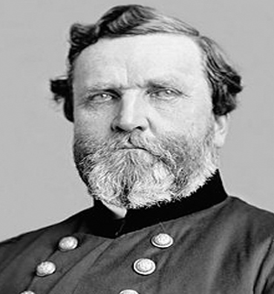
Known as “the Rock of Chickamauga” and “Pap Thomas” to his men, Thomas won the Union’s first key victory at the Battle of Mills Spring in January 1862. He “earned his spurs” at the Battle of Chickamauga, where Thomas held on in the center while his army's commander fled the field; Thomas’ stubborn refusal to retreat saved the Union army that day and earned him his sobriquet, “the Rock of Chickamauga.” After William T. Sherman detached his army to “march to the sea,” Thomas was tasked with defending Tennessee from the Confederate Army. He attacked and annihilated Confederate forces, securing the Tennessee and Union victory in the Western Theater.

6. Philip Sheridan, USA
Grant’s chief cavalry commander, Sheridan was known for his energy and aggressiveness. He first earned distinction and came to Grant's attention in the West. Brought to the Eastern Theater to command Grant's Cavalry Corps, Sheridan proved ideally suited to his new role. In May ’64 he relentlessly pursed Confederate cavalry to destruction. In response to Early’s raid on Washington, Sheridan defeated Early and scourged the Shenandoah Valley, presaging the scorched earth tactics in Sherman’s famous March to the Sea (Total War). In 1865, Sheridan’s unrelenting pursuit of the Confederate Army in Virginia led to their surrender at Appomattox. Grant summed up his service thus: “I believe General Sheridan has no superior as a general, either living or dead, and perhaps not an equal."

5. Nathan Bedford Forrest, CSA
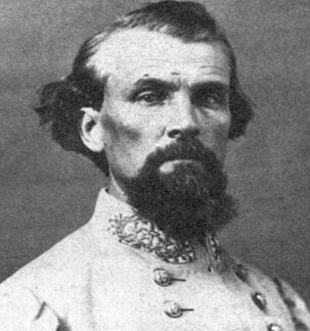
“The Wizard of the Saddle,” Forrest was not only the finest cavalry commander that America ever produced, he was a first-rate practitioner of mobile warfare and combined arms. His rapidly moving strike forces were composed of cavalry/mounted infantry, supported by batteries of horse artillery. A gifted military genius, Forrest had no formal military education, enlisting as a private at the start of the war. A very wealthy man, he soon raised his own force of cavalry, which under his leadership soon became the most feared force in the Western Theater (and he the most feared commander of the war). Throughout the war, Forrest is credited with killing, personally with his own hands, 30 enemy soldiers, the most ever by an American general. When asked after the war what the secret to his success was, Forrest responded, “By getting there first with the most men.”

4. Ulysses S. Grant, USA
The man who did more than any to win the war, it may surprise many that U.S. Grant doesn’t either head this list or come in second place. However, Grant’s virtues were not that of a great general so much as a resolute and fearless “manager” of war. Unlike the cautious George McClellan, Grant was a “fighting general” who lost little sleep concerning the enemy’s plans. After taking a terrible beating the first day at Shiloh, Sherman remarked, "Well, Grant, we've had the devil's own day, haven't we?" Grant looked up. "Yes," he replied, puffing on his cigar; "Yes. Lick 'em tomorrow, though". After a string of victories in the West, Lincoln, promoted Grant to lieutenant general—a position in the American Army previously held only be George Washington and Winfield Scott—and brought him east to take command. Over the next year, Grant proved relentless and unflappable, using his superiority in numbers and equipment to hammer Lee in ways his predecessors had failed. Unmoved by casualties, Grant continued to press Lee till the latter was forced to surrender at Appomattox Courthouse.

3. William T. Sherman, USA
The melancholy and cerebral Sherman emerged during the Civil War as perhaps the most hated (by southerners) and admired general of the war. His March to the Sea and scorched earth policy broke the economic back of the Confederacy, destroying its will to fight on (Total War). Sherman was a practitioner of maneuver warfare in contrast different than his friend and superior U.S. Grant. When Grant was sent east to take over that theater, Sherman took his place as commander in the Western Theater. Cutting himself and his army loose from their dependence on railheads for supply, he invaded Georgia in the spring of 1864. Living off the land, his “foot cavalry” continuously outmaneuvered his opponents and threatened multiple objectives, preventing Confederate forces from concentrating sufficient forces to stop him. Sherman was an early proponent of what in the 20th century came to be called “total war” (which he, himself, termed “hard war”). His strategy of destroying the economic heart of the south, as much as Grant’s aggressive campaign of relentlessly pummeling Lee, led to the South’s eventual defeat. He is the only man to have twice received the thanks of Congress during the war, and is arguably the best strategist of the Civil War.

2. Robert E. Lee, CSA
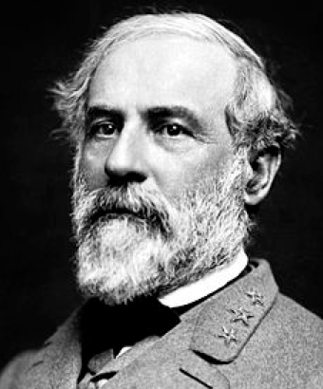
Perhaps America’s most respected general, “Marse Robert” had already obtained legendary status as America’s greatest living soldier prior the outbreak of the Civil War. He played only a minor role till June 1862, when General Joe Johnston was wounded, resulting in Lee taking command of the Army of Northern Virginia. During the Peninsula Campaign, Lee’s relentless aggressive and daring tactics drove George B. McClellan’s Army of the Potomac from the gates of Richmond. Despite heavy casualties in the process, Lee’s counter-offensive turned the tide and won him the devotion of his army. Within 90 days of taking command, Lee had driven McClellan off the peninsula, and the battle lines had moved from 6 miles outside Richmond to 20 miles outside Washington. During these two years, Lee invaded the north twice, keeping the Union forces on the defensive. In the final seasons of the Civil War, Lee employed a tenacious defensive strategy against a superior Union long after the point where a lesser general would have been defeated.

1. Thomas “Stonewall” Jackson, CSA
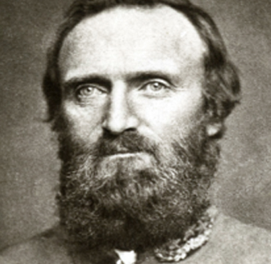
The eccentric Jackson was an instructor at Virginia Military Institute when the war broke out. Jackson joined the Confederate forces at First Bull Run. Here he became the hero of the day, earning his nickname. In what came to be called the Valley Campaign, Jackson conducted a series of brilliant operations of surprise and maneuver, covering 46 miles in 48 days and winning five significant victories. In the process, his 17,000 men defeated a combined force of 60,000 Union troops. He joined Lee for the Seven Day's Battle, beginning a partnership that was one of the great ones of the war (second only to Grant and Sherman). In the battles and campaigns that followed, Jackson’s corps was Lee’s hammer, while Longstreet’s was the anvil. The strategy proved especially fruitful at Second Manassas and at Antietam. In May of 1863, Jackson was tasked with driving rapidly south through the dense forest, below the Union forces around Chancellorsville. As the sun was low in the western sky on May 2, Jackson’s Corps unexpectedly attacked from that direction. The Union forces were caught completely by surprise, and only the fall of darkness prevented the route of Hooker’s entire army. While conducting a reconnaissance that evening beyond his lines, Jackson was accidentally fired upon and wounded by his own guards. His wounded left arm was amputated, leading Lee to comment, “General Jackson has lost his left arm; but I have lost my right.” The wound turned infected, and Jackson died in bed on May 10, 1863. His death deprived Lee of his best Corps commander, the best general of the war on either side. Had he lived to fight at Gettysburg a month later, the outcome of that battle may have been very different.

